**Exploration of Data**

Chest pain type by Age:

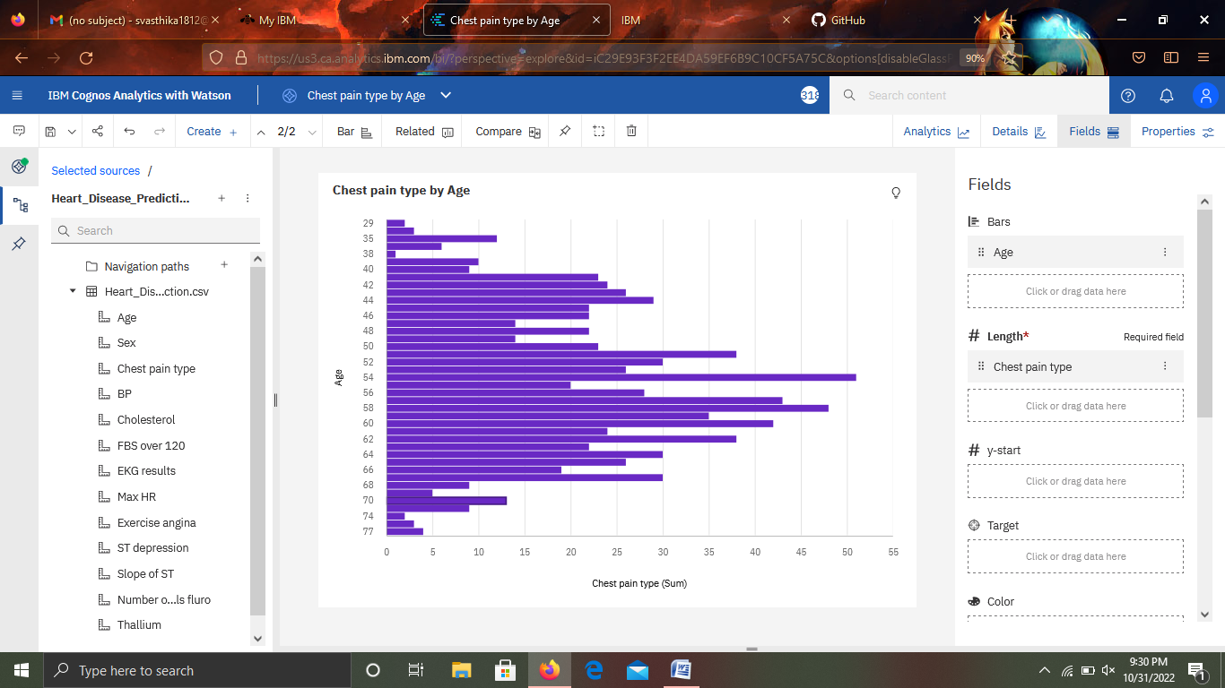

<https://us3.ca.analytics.ibm.com/bi/?perspective=explore&pathRef=.my_folders%2FChest%2Bpain%2Btype%2Bby%2BAge&subView=model000001842ec2a858_00000000>

BP by Chest pain type:

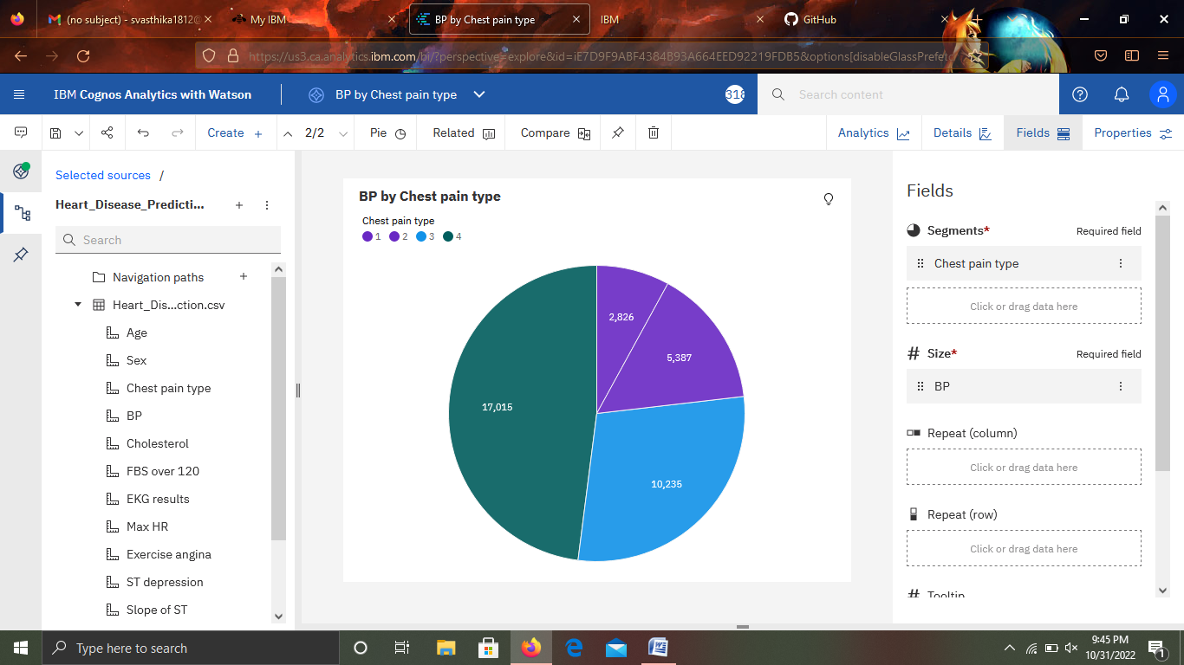

<https://us3.ca.analytics.ibm.com/bi/?perspective=explore&pathRef=.my_folders%2FBP%2Bby%2BChest%2Bpain%2Btype&subView=model000001842ed0bc12_00000000>

ST depression by Age:

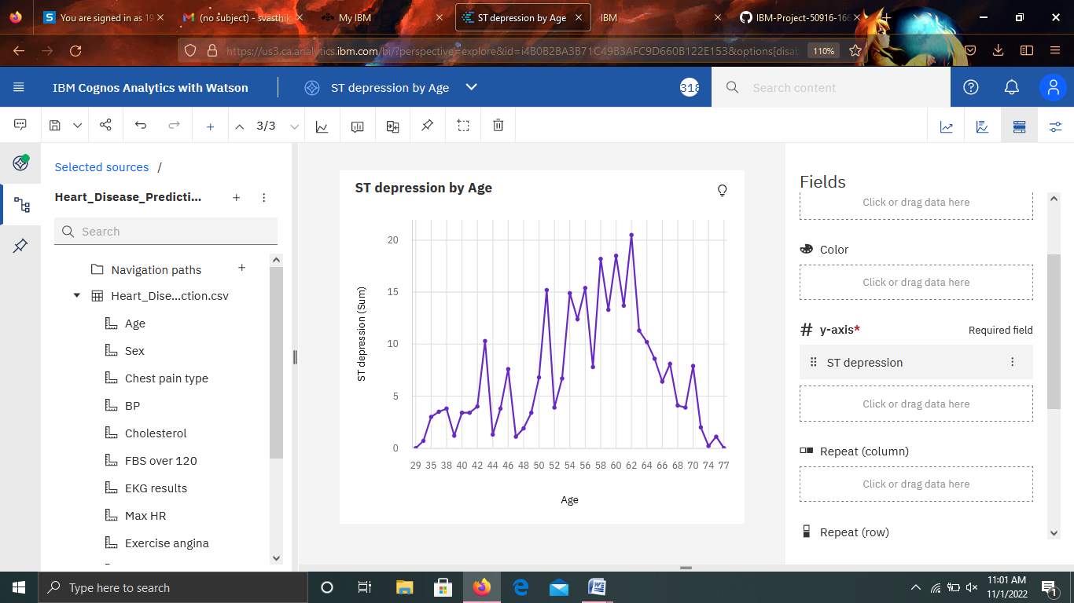

<https://us3.ca.analytics.ibm.com/bi/?perspective=explore&pathRef=.my_folders%2FST%2Bdepression%2Bby%2BAge&subView=model0000018431aa09ee_00000003>

Max HR for Sex hierarchy:

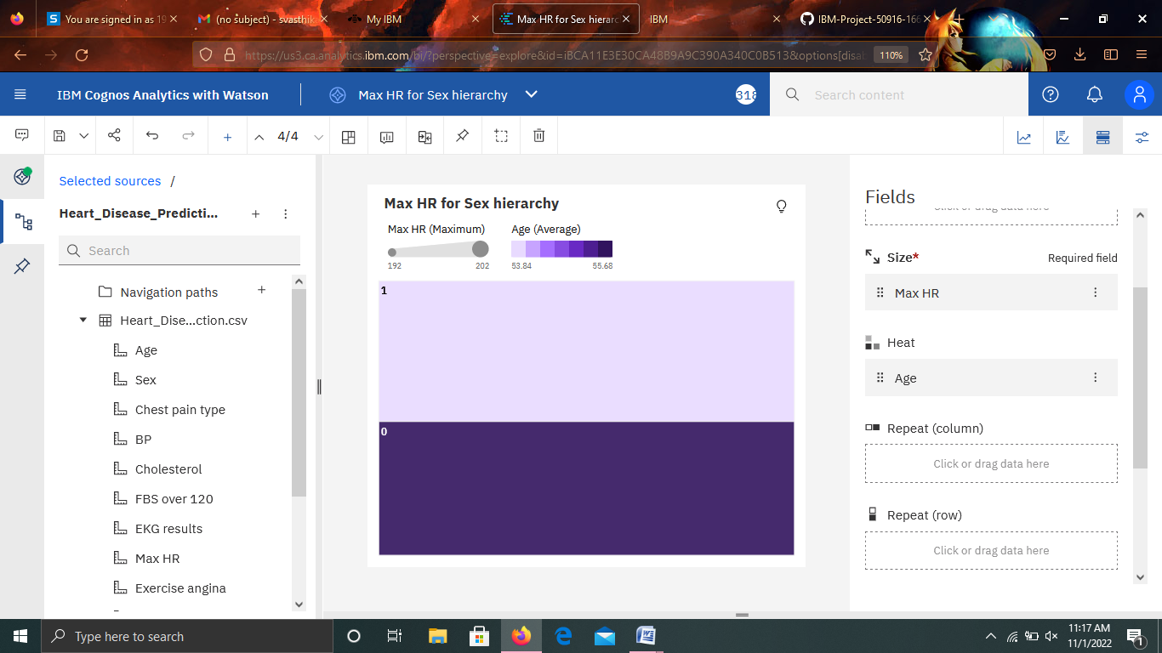

<https://us3.ca.analytics.ibm.com/bi/?perspective=explore&pathRef=.my_folders%2FMax%2BHR%2Bfor%2BSex%2Bhierarchy&subView=model0000018431af8cba_00000000>

Chest pain type, Slope of ST:

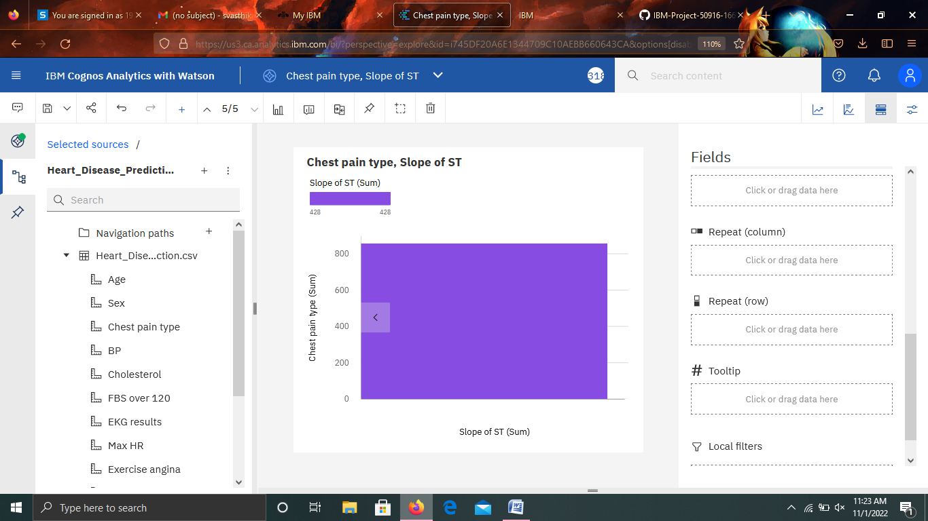

<https://us3.ca.analytics.ibm.com/bi/?perspective=explore&pathRef=.my_folders%2FChest%2Bpain%2Btype%252C%2BSlope%2Bof%2BST&subView=model0000018431bcb191_00000000>

Cholesterol by Max HR:

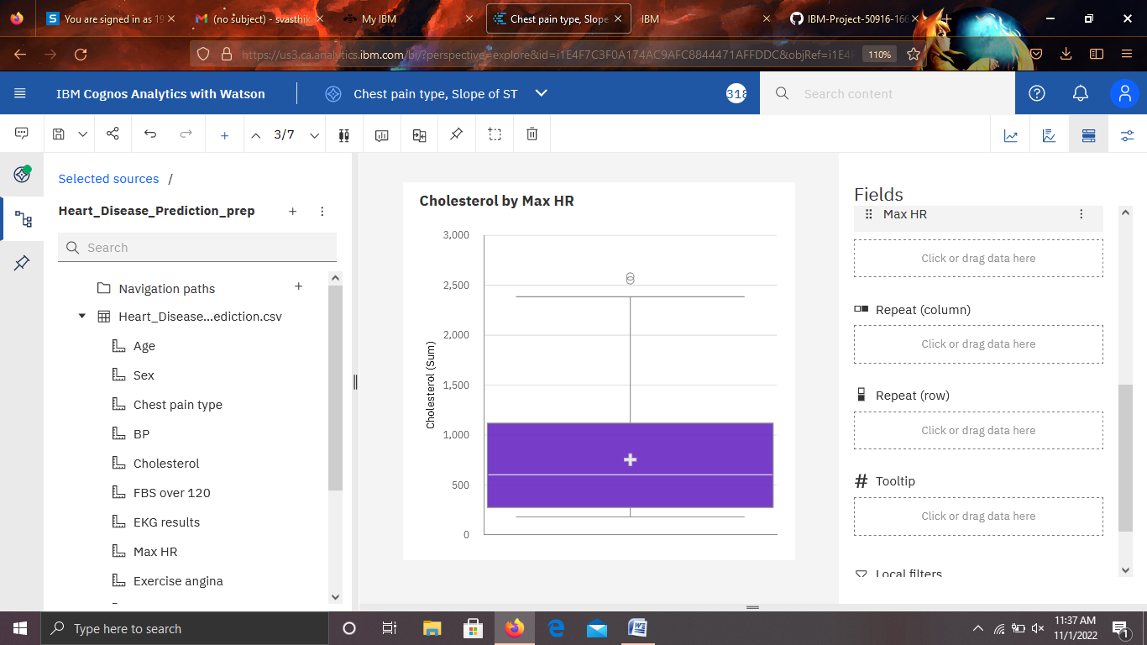

<https://us3.ca.analytics.ibm.com/bi/?perspective=explore&pathRef=.my_folders%2FCholesterol%2Bby%2BMax%2BHR&subView=model0000018431c8a785_00000000>